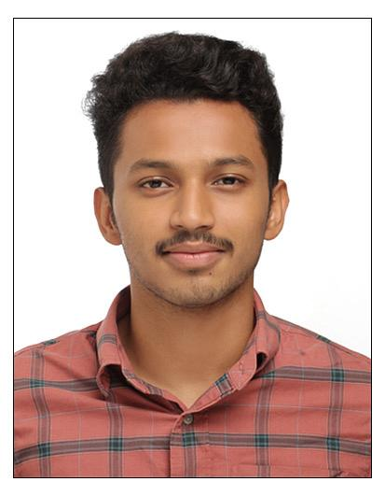
I am willing to give total support to the organization that I am in, with the knowledge and capability that I have. Seeking a challenging career in an esteemed organization, where I can fully utilize my knowledge and skills, while making a significant contribution to the success of the organization.
CAREER OBJECTIVE
EDUCATIONAL QUALIFICATION

- 1 year experience in sales and marketing in self firm.

- Advanced Diploma In Logistics And Supply Chain Management
(Global Institute Of Integral Management Studies, Kochi)
    - Advanced Diploma In Logistics & Supply Chain Management From STED Council.
    - Advanced Certificate In Logistics & Supply Chain Management From World University Consortium, California, USA
    - Certificates In Logistics From Confederation Of Indian Industry- Institute Of Logistics.

- BBA HR MANAGEMENT (PURSUING)
JAIN UNIVERSITY (ONLINE)

- PlusTwo – Biology Science
SSMV HSS Edakkazhiyur (Kerala Board Of Higher Secondary)

PERSONAL DETAILS
Father Name:KP Kabeer
Date of Birth : 24/12/2000
Sex : Male
Nationality : Indian
Marital Status : Single
Language known:
English : Read, Write, Speak
Malayalam : Read, Write, Speak
Arabic : Read,Write
Hindi : Read,Write
- Drawing
- Football
MOHAMED AQTAS KABEER
HOBBIES
PROFESSIONAL SUMMARY
Phone No: +91 9745565590

E-mail :
mohammedaqtas@gmail.com

TECHNICAL SKILLS
- Microsoft Excel
- MS Word

DECLARATION
I hereby declare that the above-mentioned information is correct up to my knowledge and I bear the responsibility for the correctness of the above-mentioned particulars.

Place:
Date: Mohamed Aqtas Kabeer

